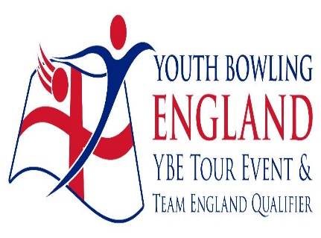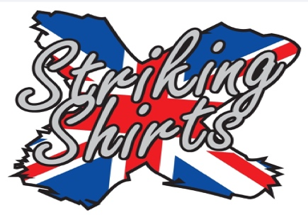
British Youth Team Open

March 13th (O/F) 19th / 20th 2022

Mansfield Superbowl
Stockwell Gate
Mansfield
Nottinghamshire
NG18 1LG

BTBA Sanction Number: 22/0048

A YBE Tour Event.

All entry forms to be emailed to brigillparker@aol.com.
Or posted to Brian Parker, 10, Oaklawn Court, Barton Road, Torquay. Devon. TQ1 4EN.
Tel 07796778321

Roll off will be 10.00am on each day (Registration 45 mins prior)
Each team will bowl six games changing lanes after each game. Odd lanes two pairs left even lanes two pairs right. A lane draw will be made before play commences.
There will be a lane redress and dinner break after three games 2 different patterns will be used.
Squads Limited to 14 teams in each.

Tournament format and divisions
This is an event for teams of 4 bowlers. There are three average based team divisions. which are defined as follows and apply to the combined team average:

- Div 1 - 480 and below
- Div 2 - 481 - 680
- Div 3 – 681 and above

All entries should be emailed to brigillparker@aol.com.
Participation in the event is subject to and conditional upon the following rules:
NOTES:

Both Freefall and string averages will be accepted without differentiation.

Before,during,and after the event there could be photography, filming or video taken of participants and medal winners by anyone attending the event, either as an official,spectator, parent or guardian.If you (as a participant,parent or guardian) object to this, you must make your objections known to the tournament manager prior to the event starting and reasonable adjustments will be made.

Tournament rules
1. The British Youth Team Open will be sanctioned by the BTBA (22/0048) and their general playing rules and tournament rules will apply, together with the following special rules and conditions.
2. The event will consist of six games, changing lanes after each game.
3. All bowlers must be current BTBA/National Federation members. BTBA membership will be checked on the membership database prior to the event. Any bowler without valid BTBA/National Federation membership will be unable to play. International bowlers must present proof of their National Federation membership at event registration.
4. Bowlers must declare their highest current average over a minimum of 18 games in any league / tour. Proof of average may be requested.
The tournament manager reserves the right to re-rate any entry without notice.
5. All bowlers must be under 22 at 31st December 2022
6. Entry fee break down per team (per person shown in brackets)
- Lineage £72.00 (£18.00)
- Prize Fund (returned 100%) £62.00 (£15.50)
- Sanction Fee £8.00 (£2.00)
- Expenses £10.00 (£2.50)
- Total entry £152.00 (£38.00)
7. Payment by BACS to Torquay Tournament Account sort code 557001 A/C No 43811132. Ref BYTO22. Entry fees to be received in full no later than Friday 04/03/22. Any changes to the team line up must be submitted by email no later than Friday 11/03/22.
8. Registration will be open 45 minutes prior to squad time. The squad may start earlier than advertised, once all teams have registered.
9. Latecomers will begin play at the frame in progress. No score will be given for the frames that were missed.
10. The Tournament Manager will be Brian Parker. All decisions made by him will be final, subject to an appeal to the BTBA. In this respect any protest must be made verbally by the team captain at the time of occurrence and confirmed in writing within 72 hours. A provisional ball shall be rolled if a dispute relating to pin fall cannot be immediately resolved.
11. Competitors will not be allowed to smoke (including electronic cigarette devices) or consume alcoholic beverages in the centre before, during, or after the tournament each day. Bad language, abuse of bowling equipment or machinery, or bringing the game into disrepute may result in disqualification by the tournament manager.
12. Competitors who, in the opinion of the tournament manager, are not dressed in a presentable manner will not be permitted to bowl. All bowlers must wear a suitable bowling shirt with the player's name or Team / YBC name clearly visible. Alcohol or tobacco sponsors are not allowed. No denim or jersey/jogging/tracksuit clothing of any description will be allowed. Only skorts, skirts, tailored shorts, trousers, ¾ length trousers or sports leggings may be worn.. Hats or other headwear will not be permitted without prior request.
Notes:
I. Sports leggings are deemed as not see-through and must not have large logos or blocks of different colours or patterns.
II. The acceptable length of tailored shorts, skirts and skorts is a length that is no shorter than the tip of the longest finger when the bowler’s arms are resting by their side.
III. Tailored shorts and trousers do not include cargo / combat style and must not have extra pockets or other decoration and must not have large logos or blocks of different colours / patterns. Additionally, trousers and shorts must have belt loops.
IV. Trousers must not have elasticated ankle bands
13. Mobile Phones and MP3 players (or other similar devices) must be turned off and are not allowed in the players area. No earphones / headphones are to be worn during play.
14. During play, excluding registered competitors, only licensed coaches or officials displaying valid licenses will be allowed in the playing area (BTBA Rule 333). Safeguarding licenses must always be visible and coaches must be appropriately dressed (as per rule 13, above).
15. Failure to comply with these rules may result in disqualification without refund.

Entry Form

Bowlers must play in order they are entered below.

Bowler 1: ______________________ BTBA No ______ Avg ____

Bowler 2: ______________________ BTBA No ______ Avg ____

Bowler 3: ______________________ BTBA No ______ Avg ____

Bowler 4: ______________________ BTBA No ______ Avg ____

Date Required : _____ Total Avg _____

(13/03/2022 O/F) ____Overflow only open when other squads are full
19/03/2022 ____
20/03/2022 ____

Contact Name:- __________________________

Contact Number:- _________ Email:- _________________

Maximum of 14 teams per squad
Closing Date for Entries 04/03/22

