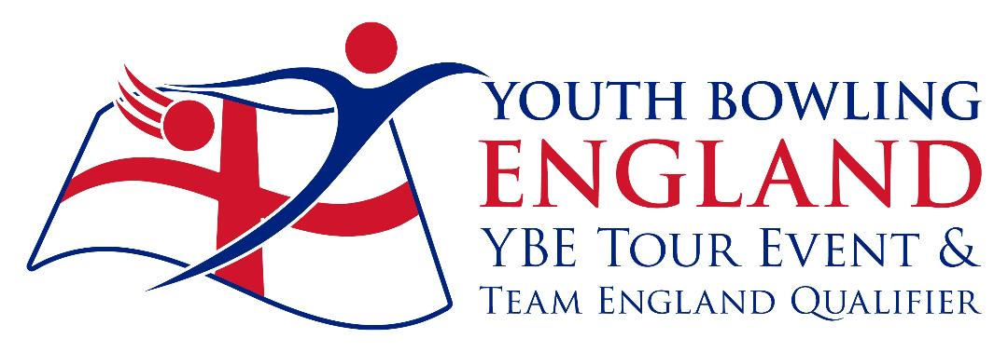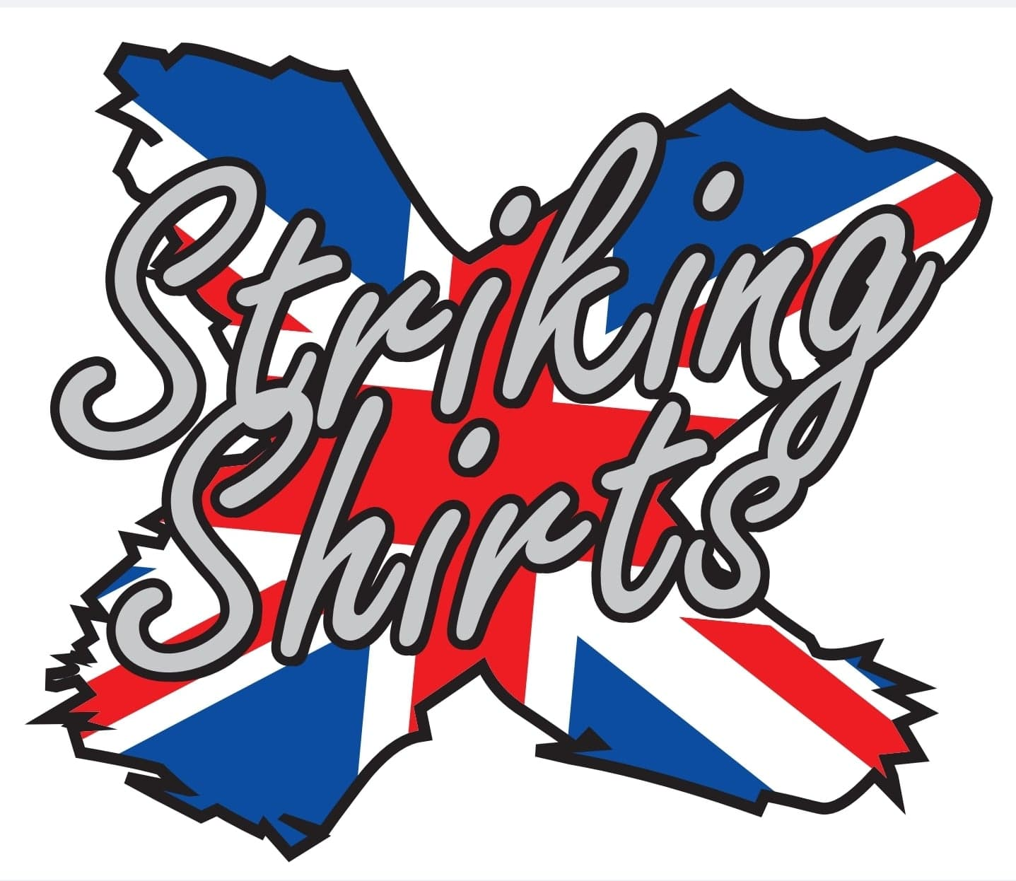
AMF Torquay
Torwood Street, Torquay.
The Torquay

Junior Doubles 2022
Saturdays & Sundays
2nd / 3rd – 9th / 10th
April 2022

BTBA Sanction Number:- 22/0049

Both freefall and string averages will be accepted without differentiation
Before, during and after the event there could be photography, filming or video taken of participants and medal winners by anyone attending the event, either as an official, spectator, parent or guardian. If you (as a participant, parent or guardian) object to this, you must make your objections known to the tournament manager prior to the event starting and reasonable adjustments will be made.

Entry Form 2022

Name M/F Average D.O.B. B.T.B.A. No
(In playing Order) Team Name:-
Total Team Average:- Division:-
Total Team Average:- Division:-
Total Team Average:- Division:-
Total Team Average:- Division:-

Squad Times
02/04/22 Sqd “A” 09.00 Sqd “B” 13.30
03/04/22 Sqd”C” 09.00 Sqd “D” 13.30
09/04/22 Sqd “E” 09.00 Sqd “F” 13.30
10/04/22 Sqd “G” 09.00 Sqd “H” 13.30
Registration 30mins prior to roll off.
Maximum 12 teams per squad.
Y.B.C.
Contact Name Address
Tel / Email
Squad Required 1st choice 2nd Choice
Rules and Conditions

This is a YBE Tour event and a team England Qualifier and will be sanctioned by the B.T.B.A. their rules will govern this event along with the following rules and conditions. The tournament is open to B.T.B.A members and membership will be checked on the website.

This will be a scratch doubles event throughout with teams being split into four average groups, Div 1:- Combined Avg of 351 and above, Div 2:- 291 to 350, Div 3:- 246 to 290, Div 4:- 245 and below. Each team will bowl eight games changing lanes after every two games.

Entrants must declare their highest average in any league, tournament or merit table (Junior or adult) over 21 games on the day of bowling.

The tournament manager, Brian Parker, Reserves the right to refuse or rerate any he considers just cause to do so. Any protests must be lodged by YBC official / Bowler within 30 mins and confirmed in writing within 72 hours. A provisional ball must be rolled if a dispute relating to pinfall cannot be resolved immediately. The tournament manager’s decision is final subject to an appeal to the B.T.B.A.

No bowler is allowed to drink alcohol anywhere in the bowling centre during the tournament. Profane language or the abuse of bowling equipment / Machinery may result in disqualification. Any bowler disqualified will be reported to the B.T.B.A.

Competitors should wear suitable bowling attire, shirts should contain either YBC / Bowlers names. Denim is not allowed, dress shorts may be worn. YBC officials / coaches should also follow the YBE dress code. Mobile phones should not be taken into the bowler’s area during play.

Only bowlers, tournament officials or one licensed instructor / coach per team are allowed in the playing area. Instructors / coaches should display their licences.

Closing date for entries will be 25/03/22. (Please note I will be away form 25/02/22 to 10/03/22)

Entry fees must be paid in full by the closing date. No entry fees will be refunded after squadding except in the case of the tournament being cancelled.

Entry fee will be £76.00 (£38.00 per bowler). To include £10.00 prize fund and £2.00 sanction fee. Bank transfer to:- Torquay Tournament A/C Sort code:- 557001. A/C No 43811132 ref TD22 and bowlers / YBC name. Or by cheque payable to Torquay Tournament Account and forwarded along with entry form to Brian Parker, 10, Oaklawn Court, Barton Road, Torquay, TQ1 4EN.
Tel 07796778321 Email brigillparker@aol.com website www.bptournaments.org.uk

