2022 North of England Youth
Combination Trios
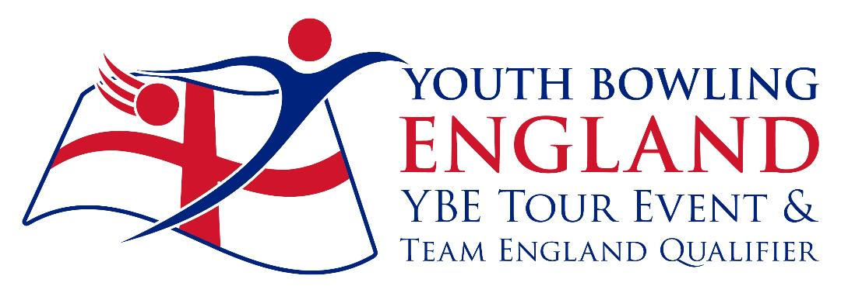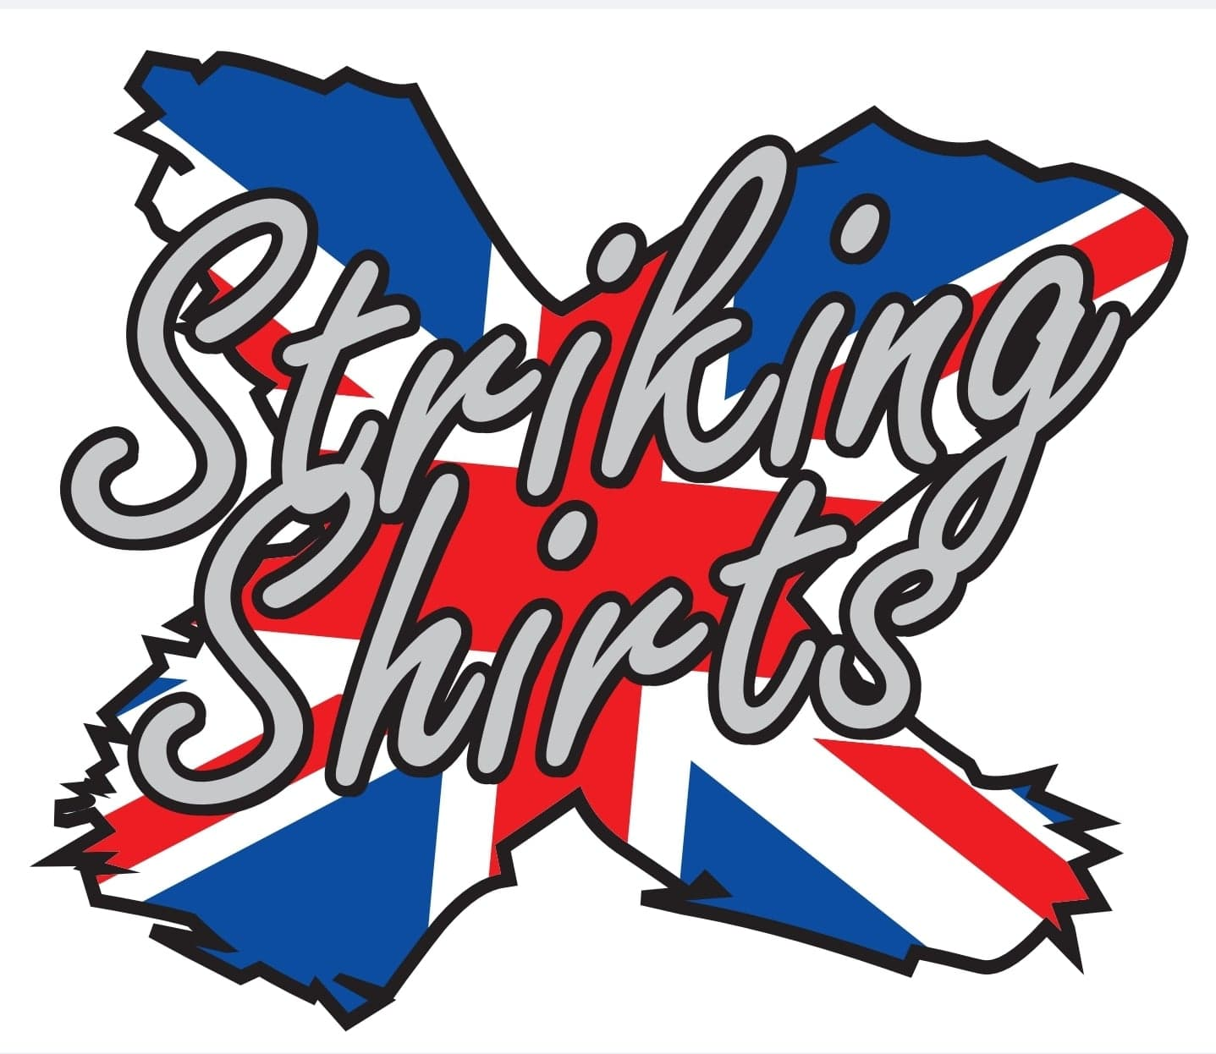
To Be Held At:
Mansfield Superbowl
Sockwell Gate
Mansfield
NG18 1LG

B.T.B.A. Sanction Number:- 22/0051

Saturdays and Sundays
2/3 and 9/10 July 2022
Format
All bowlers will bowl six games, three as either singles or doubles and three as trios

Both Free Fall and String averages will be accepted without differentiation
Please be aware before, during and after the event there could be photography, filming or video taken of participants and medal winners by anyone attending the event, either as an official, spectator, parent or guardian. If you (as a participant, parent or guardian) object to this you must make your objections known to the tournament manager prior to the event starting and reasonable adjustments will be made.

Closing date for entries will be 24/06/2022
Tournament Rules and Conditions
- This is a Y.B.E. bowling tour event and a Y.B.E. Team England qualifying event, and will be sanctioned by the B.T.B.A. and their rules will govern the event with the following rules and conditions.
- All bowlers must be under 22 at 31st December 2022, and must be members of the B.T.B.A. memberships will be checked on the B.T.B.A. website.
- Closing date for entries is the 24th June 2022 and all entry forms / payments must be made by this date, incomplete entries will not be squaded until all details are received. Entry Fees will not be refunded once squading is done, except for cancellation of tournament
- Registration will be 30 mins prior to each squad. If all bowlers are present and registered then bowling may commence earlier. Latecomers will commence game at the frame in progress. Team changes should be notified to the tournament manager at least 72 hours prior to date of bowling.
- Competitors, who in the opinion of the tournament manager, are not dressed in the correct attire in the players area may not be permitted to bowl. Bowlers should adhere to the laid down Y.B.E. dress code.
- No competitor will be allowed to consume alcoholic beverages anywhere in the centre during the tournament. Profane language and/or abuse of the bowling equipment / Machinery may result in disqualification of the individual from the event. Any bowler disqualified will be reported to the B.T.B.A. for consideration of disciplinary procedure.
- Protests of any nature must be lodged to the tournament manager within 30 mins of the problem occurring, and confirmed in writing before the presentation commences. A provisional ball must be rolled if a dispute over pinfall cannot be resolved immediately.
- Only Bowlers, tournament officials or one licensed instructor/coach will be allowed in the bowlers area during play. Instructors/coaches must wear their licences.
- Points will be awarded to all bowlers in line with the Y.B.E. tour guidelines.
- In the event of a tie winners will be decided by the highest low game.
- Bowlers must declare their highest average, over 21 games, in any (adult or junior) League, Tournament or merit table on the day of bowling.
- An up to date standing sheet should be sent to the tournament manager seven days prior to date of bowling.
- Competitors must have already bowled in the tournament before they can pace.
- Entry forms must contain all information required and be sent to:- Brian Parker, 10, Oaklawn Court, Barton Road, Torquay, TQ1 4EN. Or to email brigillparker@aol.com. Along with full payment, £108.00 (£36.00 p.p.) to include £36.00 P.F. £72.00 lineage, expenses to include £2.00 sanction fee, by bank transfer to North of England Open, Sort code 557001, A/C No 74542729 Ref NOE22 and YBC/bowlers name. Or cheques made payable to North of England Open.

Format.
All bowlers will bowl 6 games, 3 as either singles or doubles and three as a trios. Bowlers will bowl in the following average divisions.
Singles Male and Female
Div 1, Up to 110 / Div 2, 111 to 140 / Div 3, 141 to 170 / Div 3, 171 and above
Doubles Mixed
Div 1,Up to 220 / Div 2, 221 to 280 / Div 3, 281 to 340 / Div 4, 341 and above.
Team Mixed.
Div 1, Up to 330 / Div 2, 331 to 420 / Div 3, 421 to510 / Div 4, 511 and above

Combination Trios Entry Form 2022.
Bowlers must bowl trios in order on the form.
Name M/F Avg B.T.B.A. No D.O.B. Sngls/Dbls

Total Average:-
Total Average:-
Total Average:-
Squad Details
Squad Date Reg Squad Date Reg Squad “A” 02/07/22 08.30 Squad “B” 02/07/22 13.00
Squad “C” 03/07/22 08.30 Squad “D” 03/07/22 13.00
Squad “E” 09/07/22 08.30 Squad “F” 09/07/22 13.00
Squad “G” 10/07/22 08.30 Squad “H” 10/07/22 13.00
Squads A-C-E-G Squads B-D-F-H
Singles 09.00 Singles 13.30
Doubles 09.45 Doubles 14.15
Trios 11.00 Trios 15.30
Contact Details.
Y.B.C.

Contact Name / Address.

Tel / Email
Squad Required
1st Choice 2nd Choice

