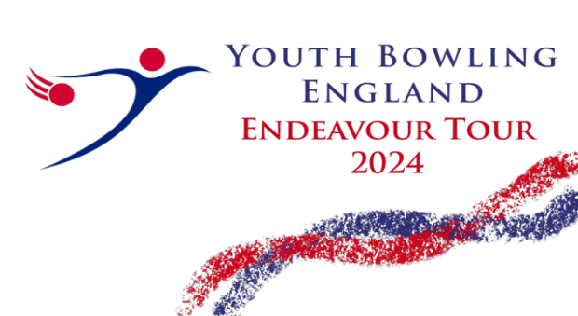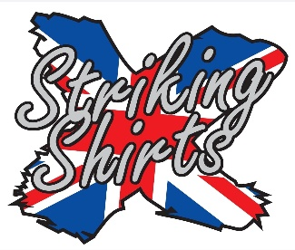
Mansfield Bowl
The Bowlers Club 2024

Open to all bowlers under 22 as at 31st December 2024
Saturdays & Sundays
Round 1 – 24th/25th February 2024
Round 2 – 1st/2nd June 2024
Round 3 – 27th/28th July 2024
Final 7th/8th September 2024
(Saturdays are overflow)

BTBA Sanction No – 24/00336
All entry forms should be forwarded to:-
Brian Parker, 10, Oaklawn Court, Barton Road, Torquay
Devon. TQ1 4EN.
Payment by Bank Trans to:- A/C name The Bowlers Club,
Sort Code, 557001. A/C No 74806378
Email:- brigillparker@aol.com
Tel:- 07796778321
Web site www.bptournaments.org.uk
Both Free fall and string averages will be accepted without differentiation
Before, during and after the event there could be photography, filming or video taken of participants and medal winners by anyone attending the event, either as an official, spectator, parent or guardian. If you (as a participant, parent or guardian) object to this you must make your objections known to the tournament manager prior to the event starting and reasonable adjustments will be made.

Mansfield Bowl.
The Bowlers Club 2024
Rules and Conditions

- This is a YBE discovery tour event and will be sanctioned by the BTBA. Their rules will govern the event with the following special rules and conditions.
- This will be a scratch tournament throughout with bowlers being split into four average groups:- Div A: 176 and above, Div B: 151 to 175 Div C: 126 to 150 Div D: 101 to 125 Div E: up to 100. All entrants must be BTBA or equivalent national members.
- Entrants must declare their highest average in any league, tournament or merit table (Junior or Adult) over 18 games. YBC officials should submit a current proof of averages 7 days before the tournament commences.
- The tournament manager, Brian Parker, Reserves the right to refuse or rerate any entry if he considers there is just cause to do so. Protests must be lodged by the YBC official / bowler within 30 mins and confirmed in writing within 72 hours. A provisional ball must be rolled if a dispute relating to pinfall cannot be resolved immediately. The tournament manager’s decision is final subject to appeal to the BTBA.
- No competitor will be allowed to smoke or consume alcohol anywhere in the centre during the tournament. Any breach of this rule will result in immediate disqualification of the individual concerned. Profane language, improper gestures or abuse of any bowling equipment / machinery may also result in disqualification. Any individual disqualified will be reported to the BTBA.
- Bowlers should be dressed in appropriate bowling attire, shirts should contain YBC / Bowlers name. Mobile phones etc should be left outside the bowlers area once play has started. YBE dress code should be followed.
- Only tournament officials, bowlers and one coach per bowler are allowed in the bowlers area. YBC Officials, instructors and coaches must adhere to the dress code.
- Closing date for entries will be the 7 days before each round. All entry forms and payments to be submitted by then.
- There will be a limit of 35 bowlers in each squad.
- Payment should be made by bank transfer to:- Name: The Bowlers Club, Sort code: 557001, A/C No: 74806378. Entry fee will be £42.00 for the first entry then £40.00 for the others, of which 10.00 will be prize fund. ( Sanction fee 2.00 paid with first entry )

Squad Times will be: - Sundays 09.00 and 13.00
Registration 08.30 and 12.30
Format
All bowlers will bowl 6 games changing lanes after every 2.
The winners will be the highest scratch score in each division.
Any ties will be decided by the highest low game.
All bowlers will qualify for the final providing they have bowled in at least two rounds.

The Bowlers Club 2024
Entry Form

Name:- _________________________________________
Email Address: - __________________________________________________
Telephone:- Year of Birth:-
BTBA Number:- Y.B.C.:-
Secretary / Contact: - __________________________________________
All Averages: -

Signed

1 2 3 All
Round Applied For:- ____ ____ ____ ____

Squad Required :- Sunday AM ___ PM ___

Entries taken on a first come first served basis. If entering by phone spots will be saved for 72 hours before payment is required.
Prize Fund will be paid 1 in 10 entries

