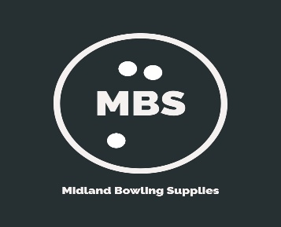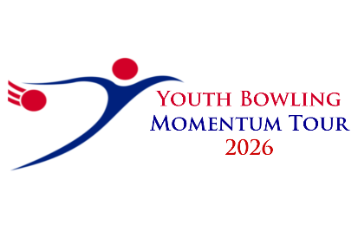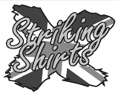

The Bowlers Club 2026

Sanction Number | 26/00655
When | Saturdays / Sundays  Round 1, 7th – 8th February. Round 2, 30th / 31st May.  Round 3, 25th / 26th July. Final 5th / 6th September.
Where | Mansfield Super Bowl, Stockwell Gate, NG18 1LG. 01623 462000
Format | Singles. (6 Games changing every 2.)
Scratch | Scratch, grouped by average divisions  Div A, 176 and above  Div B, 151 to 175  Div C, 126 to 150  Div D, 101 to 125  Div E, up to 100
Squads | A / C - 8:30am registration, 09;00am start  B / D – 12:30pm registration, 13:00pm start
Entry Fee | £45.00 first entry £43.00 all others Held from last year
Entry Closing Date | 7 days prior to date of bowling

Both Free Fall and String averages will be accepted without differentiationPlease be aware before, during and after the event there could be photography, filming or video taken of participants and medal winners by anyone attending the event, either as an official, spectator, parent or guardian. If you (as a participant, parent or guardian) object to this you must make your objections known to the tournament manager prior to the event starting and reasonable adjustments will be made.

Mansfield Bowl.
The Bowlers Club 2026
Rules and Conditions

- This is a YB tour event and will be sanctioned by the BTBA. Their rules will govern the event with the following special rules and conditions.
- All entrants must be under 20 at 31st Dec 2026 and BTBA or equivalent national members.
- Starting averages will be based on last seasons bowlers club finishing average (min 12 games) Anyone who didn’t bowl 12 games or is new to the bowlers club will enter on their highest YBC, league / tour average over 18 games. Averages will be adjusted each round on average bowled. Final average will be calculated on all rounds bowled. Please note this is for the Bowlers Club only.
- The tournament manager, Brian Parker, Reserves the right to refuse or rerate any entry if he considers there is just cause to do so. Protests must be lodged by the YBC official / bowler within 30 mins and confirmed in writing within 72 hours. A provisional ball must be rolled if a dispute relating to pinfall cannot be resolved immediately. The tournament manager’s decision is final subject to appeal to the BTBA.
- No competitor will be allowed to smoke, vape or consume alcohol anywhere in the centre during the tournament. Any breach of this rule will result in immediate disqualification of the individual concerned. Profane language, improper gestures or abuse of any bowling equipment / machinery may also result in disqualification. Any individual disqualified will be reported to the BTBA.
- Bowlers should be dressed in appropriate bowling attire, shirts should contain YBC / Bowlers name. Mobile phones etc should be left outside the bowlers area once play has started. YB dress code should be followed.
- Only tournament officials, bowlers and one coach per bowler are allowed in the bowlers area. YBC Officials, instructors and coaches must adhere to the dress code.
- Closing date for entries will be 7 days prior to each round. All entry forms and payments to be submitted by then.
- There will be a limit of 35 bowlers in each squad, (28 Saturday) A £10.00 deposit is required within 72hours when applying to confirm booking.
- Payment should be made by bank transfer to:- Name: The Bowlers Club, Sort code: 557001, A/C No: 74806378. Entry fee will be £45.00 for the first entry then £43.00 for the others, of which £10.00 will be prize fund. (Sanction fee £2.00 paid with first entry only)

Entry Form

BTBA | Name | YOB | Highest Avg

YBC | Contact Name | Telephone | Email

Squad Choice | A (overflow) | B | C | D
Please indicate 1st and 2nd choice

Format
All bowlers will bowl 6 games changing lanes after every 2.
The winners will be the highest scratch score in each division.
Any ties will be decided by the highest low game.
All bowlers will qualify for the final providing they have bowled in at least two rounds.

