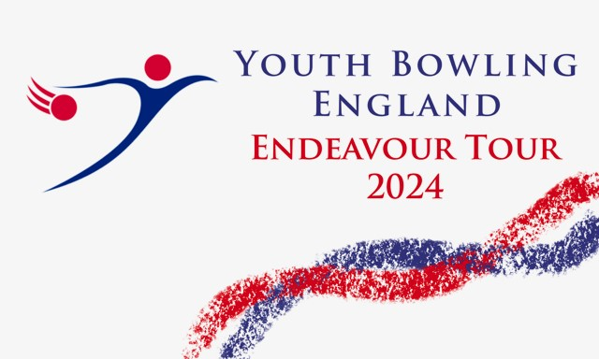
2024 North of England
Diamond Trios
Ashby Bowl
Grange Lane
Ashby
Scunthorpe
DN16 3BJ
01742 852852
BTBA Sanction Number:- 24/00423
Saturday and Sunday
6th/7th – 13th/14th July 2024
Format
All bowlers will bowl nine games, Singles, Doubles and Trios

Both Free Fall and String averages will be accepted without differentiation
Please be aware before, during and after the event there could be photography, filming or video taken of participants and medal winners by anyone attending the event, either as an official, spectator, parent or guardian. If you (as a participant, parent or guardian) object to this you must make your objections known to the tournament manager prior to the event starting and reasonable adjustments will be made.
Closing Date for Entries 30th June 2024
Maximum 12 teams per squad
Tournament Rules and Conditions
This is a YBE discovery tour event and will be sanctioned by the BTBA and their rules will govern the event with the following rules and conditions.
- All bowlers must be under 22 at 31st December 2024, and must be members of the BTBA. Memberships will be checked on the BTBA website.
- Closing date for entries is the 28th June 2024 and all entry forms / payments must be made by this date. Incomplete entries will not be squadded until all details are received. Entry Fees will not be refunded once squadding is done, except for cancellation of the tournament
- Registration will be 30 mins prior to each squad. If all bowlers are present and registered then bowling may commence earlier than scheduled. Late comers will commence the game at the frame in progress. Team changes should be notified to the tournament manager at least 72 hours prior to date of bowling.
- Competitors, who in the opinion of the tournament manager, are not dressed in the correct attire in the players area may not be permitted to bowl. Bowlers should adhere to the laid down YBE dress code.
- No competitor will be allowed to consume alcoholic beverages anywhere in the centre during the tournament. Profane language and/or abuse of the bowling equipment / Machinery may result in disqualification of the individual from the event. Any bowler disqualified will be reported to the BTBA for consideration of disciplinary procedure.
- Protests of any nature must be lodged to the tournament manager within 30 mins of the problem occurring, and confirmed in writing before the presentation commences. A provisional ball must be rolled if a dispute over pinfall cannot be resolved immediately.
- Only Bowlers, tournament officials and one licensed instructor/coach will be allowed in the bowlers area during play. Instructors/coaches must wear their licences.
- Points will be awarded to all bowlers in line with the YBE tour guidelines.
- In the event of a tie winners will be decided by the highest low game.
- Bowlers must declare their highest average, over 18 games, in any (adult or junior) League, Tournament or merit table on the day of bowling.
- An up to date standing sheet should be sent to the tournament manager seven days prior to date of bowling.
- Competitors must have already bowled in the tournament before they can pace.
- Entry forms must contain all information required and be sent to:- Brian Parker, 10, Oaklawn Court, Barton Road, Torquay, TQ1 4EN. Or to email brigillparker@aol.com. Along with full payment, £160.00. to include £30.00 P.F. £108.00 lineage, expenses to include £6.00 sanction fee, by bank transfer to North of England Open, Sort code 55 70 01, A/C No 74542729 Ref NOE24 and YBC/Team name.
Money should be paid per team not individually.
Format.
All bowlers will bowl 9 games, 6 as either singles or doubles and three as a trio (27 games). Bowlers will bowl in the following average divisions.
Singles Mixed
Div 1, Up to 125 / Div 2, 126 to 165 / Div 3, 166 and above
Doubles Mixed
Div 1, Up to 250 / Div 2, 251 to 330 / Div 3, 331 and above.
Team Mixed.
Div 1, Up to 375 / Div 2, 376 to 495 / Div 3, 495 and above

Diamond Trios Entry Form 2024.
Bowlers must bowl in order on the form.

Name Average BTBA No Year of Birth M/F

1
2
3

Total Average:- ______________

Squad Details
Date Reg Date Reg Squad “A” 06/07/2024 08.30 Squad “C” 13/07/2024 08.30
Squad “B” 07/07/2024 08.30 Squad “D” 14/07/2024 08.30
Singles 09.00 (Bowler 1) Lane Dressing 12.30 approx
Doubles 09.45 (Bowlers 1 + 2) Doubles 13.30 (Bowlers 2 + 3)
Trios 11.00 (bowlers 1 + 2 + 3) Singles 14.45 (Bowler 3)
Finish 15.30 approx..

Contact Details.
Y.B.C.

Contact Name.

Tel / Email
Squad Required
1st Choice 2nd Choice

