Y.B.E. Doubles North 2024
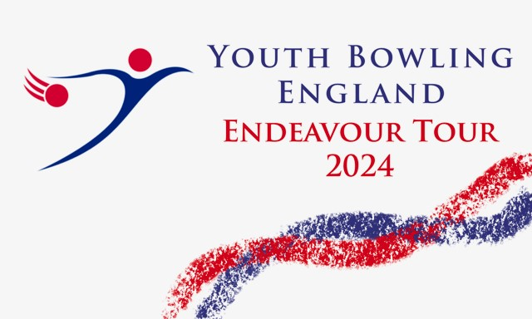
To Be Held At:
Mansfield Superbowl
Stockwell Gate
Mansfield
NG18 1LG
B.T.B.A. Sanction Number:- 24/00422
Saturday andSunday
05th / 06th October 2024
Format
All bowlers will bowl six games.
Both Free Fall and String averages will be accepted without differentiation
Please be aware before, during and after the event there could be photography, filming or video taken of participants and medal winners by anyone attending the event, either as an official, spectator, parent or guardian. If you (as a participant, parent or guardian) object to this you must make your objections known to the tournament manager prior to the event starting and reasonable adjustments will be made.

Closing date for entries will be 27/09/2024

Tournament Rules and Conditions

- This is a Y.B.E. bowling tour event and will be sanctioned by the BTBA. and their rules will govern the event with the following rules and conditions.
- All bowlers must be under 22 at 31st December 2024, and must be members of the BTBA. Memberships will be checked on the BTBA. website.
- Closing date for entries is the 27th September 2024 and all entry forms / payments must be made by this date. Incomplete entries will not be squadded until all details are received. Entry Fees will not be refunded once squadding is done, except for cancellation of the tournament
- Registration will be 30 mins prior to each squad. If all bowlers are present and registered then bowling may commence earlier than scheduled. Latecomers will commence the game at the frame in progress. Team changes should be notified to the tournament manager at least 72 hours prior to date of bowling.
- Competitors, who in the opinion of the tournament manager, are not dressed in the correct attire in the players area may not be permitted to bowl. Bowlers should adhere to the laid down Y.B.E. dress code.
- No competitor will be allowed to consume alcoholic beverages anywhere in the centre during the tournament. Profane language and/or abuse of the bowling equipment / Machinery may result in disqualification of the individual from the event. Any bowler disqualified will be reported to the B.T.B.A. for consideration of disciplinary procedure.
- Protests of any nature must be lodged to the tournament manager within 30 mins of the problem occurring and confirmed in writing before the presentation commences. A provisional ball must be rolled if a dispute over pinfall cannot be resolved immediately.
- Only Bowlers, tournament officials or one licensed instructor/coach will be allowed in the bowlers area during play. Instructors/coaches must wear their licences.
- Points will be awarded to all bowlers in line with the Y.B.E. tour guidelines.
- In the event of a tie winners will be decided by the highest low game.
- Bowlers must declare their highest average, over 18 games, in any (adult or junior) League, Tournament or merit table on the day of bowling.
- An up to date standing sheet should be sent to the tournament manager seven days prior to date of bowling.
- Competitors must have already bowled in the tournament before they can pace.
- Entry forms must contain all information required and be sent to:- Brian Parker, 10, Oaklawn Court, Barton Road, Torquay, TQ1 4EN. Or to email brigillparker@aol.com. Along with full payment of £80.00 to include £20.00 P.F. £48.00 lineage. Expenses to include £4.00 sanction fee, by bank transfer to Torquay Tournament Account, Sort code 557001, A/C No 43811132 Ref Dbls24 and YBC / Bowlers name.
- Format.
All bowlers will bowl 6 games, Changing lanes every 2 games. Bowlers will bowl in the following 4
average divisions.
( Maximum 14 teams per squad )

Doubles
Div A, 341 and above / Div B, 281 to 340 / Div C, 221 to 280 / Div D, up to 220.

YBE Doubles North
Entry Form 2024.
Bowlers must bowl in order on the form.
Name M/F Highest Avg B.T.B.A. No D.O.B.

Total Average:-
Total Average:-
Total Average:-
Squad Details
Squad Date Reg Squad Date Reg “B” 06/10/24 09.00 “C” 06/10/24 12.00
(SQUAD “A” 05/10/24 12.00 Reg)

Contact Details.
Y.B.C.

Contact Name / Address.

Tel / Email
Squad Required
1st Choice 2nd Choice

