A BTBA / YB Tour and YTE Qualification Event
_____________________________________________________________
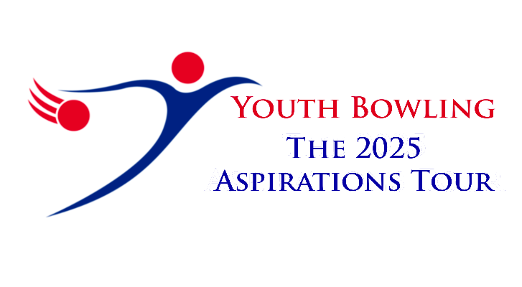Presents the
57th BTBA YOUTH NATIONAL CHAMPIONSHIPS
_______________________________________________

At
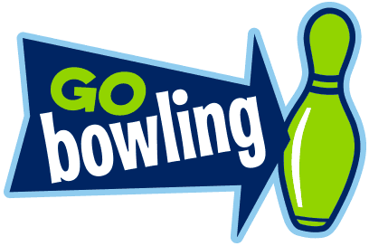
GO BOWLING
COURT DRIVE
DUNSTABLE
LU5 4JD

On
13th/14th - 20th/21st September 2025
Closing Date For Entries: 17th August 2025

BTBA SANCTION NO: 25/00562

ELIGIBILITY
This tournament is open to all members of Youth Bowling Clubs which are registered with the National Association that are affiliated to the British Tenpin Bowling Association. Competitors must be members of their National Association and may only represent one Youth Bowling Club in which they are a member. All doubles pairings and team members can be from the same YBC or in partnership with another YBC. If YBC’s agree to partner all bowlers from both YBC’s must bowl under the same partnership. All bowlers must be under the age of 22 on the 31st December 2025.
AVERAGE DIVISIONS
DIVISION A Averages 181 and over
DIVISION B Averages 161 up to 181
DIVISION C Averages 141 up to 160
DIVISION D Averages 121 up to 140
DIVISION E Averages 101 up to 120
DIVISION F Averages up to 100
Entrants must declare their highest average from any Junior League or the YB Tour merit table over 18 games. An up to date standing sheet should be sent to the tournament manager 7 days before tournament commences.
CHAMPIONSHIP EVENTS
- BOY’S AND GIRL’S SINGLES EVENT
  - All average divisions
  - Age based divisions – U10, U13, U16, U19 and U22

- DOUBLES EVENT
  - Division A - combined average of 361 and over
  - Division B - combined average of 321 to 360
  - Division C - combined average of 281 to 320
  - Division D - combined average of 241 to 280
  - Division E - combined average of 201 to 240
  - Division F - combined average of up to 200
All average divisions may be made up of any combination (2 boys, 2 girls or mixed)
- FOUR PERSON TEAM EVENT
  - Division A – combined average of 681 and over
  - Division B – combined average of 601 to 680
  - Division C – combined average of 521 to 600
  - Division D – combined average of 441 to 520
  - Division E – combined average of up to 440
All average divisions may be made up of any combination.
- BOY’S AND GIRL’S ALL EVENTS
  - All average divisions
  - Age based divisions – U10, U13, U16, U19 and U22
All bowlers entering the three events are automatically entered in this category. Bowlers may be entered in the doubles and team events even though they may not be part of either a pair or a full team in order to complete their 9 games.
- Athletes will enter their appropriate Average based divisions and their scratch score will be extrapolated to their corresponding Age based division.
- There will be medals for first, second and third in each event
- Scoring system shall be total scratch pinfall of bowlers rolling a three game series per event
- In the event of a tie for any placings the winners will be decided on highest low game
- Bowlers MUST bowl in the order declared on the entry form and score sheet
- Bowlers entering the tournament may not pace unless they have completed all the events for which they have been entered
- Lanes that are not used in any squad may not be used for practice by competitors prior to taking part in the event.

RULES AND CONDITIONS OF THE TOURNAMENT
- The general playing rules of the British Tenpin Bowling Association will govern this tournament along with the following special rules and conditions.
- To secure places all Entry Fees must be paid no later than 10 calendar days after the Entry Form has been received. After closing date entries can only be accepted which will either fill a place needed for a pacer or a replacement for a withdrawn bowler. It is the responsibility of the YBC official to ensure the entry form has been received. The entry fee is £18 per bowler, per event (including £2 BTBA Sanction Fee per bowler).
- Where a bowler is withdrawn and replaced the replacement bowler must take the place of the withdrawn bowler but note the following:-
  - In the team event where a replacement bowlers causes the team to move into a different division category one bowler per replacement may be switched from another team to bring the total average back down.
  - A replacement must be either a BTBA or other National Association member as at the first day of the tournament, from the same YBC and not already bowling in the particular event (singles, doubles or team)
  - Changes must be notified on the official Change Form or by email to the tournament manager.
- The Tournament Committee reserves the right to accept, re-rate or reject any entry and their decision on all matters will be final subject to the right of appeal to the BTBA.
- Protests of any nature must be lodged by the YBC registered official (see rule 11) with the tournament manager (Brian Parker) within 30 minutes of the infraction occurring and confirmed in writing before the presentation. A provisional ball must be rolled if a dispute relating to pinfall cannot be resolved immediately. No protests will be accepted once the presentation has commenced.
- No competitor will be allowed to consume alcoholic beverages anywhere in the centre during the tournament. Any breach of this rule along with bad language, gesticulation or abuse of bowling equipment, machinery or fellow competitors/officials will result in disqualification of the individual from the tournament. Any mobile phone taken into the players’ area must be switched off. Individuals whose conduct is considered liable to bring the game into disrepute will be disqualified from the tournament and will be reported to the BTBA for consideration of disciplinary proceedings, any disqualification may result in the loss of scores and awards.
- Competitors, who in the opinion of the tournament committee, are not dressed in a presentable manner will not be permitted to bowl. All bowlers must wear a suitable bowling shirt with the YBC name clearly visible on the back. Alcohol, Vapes and tobacco sponsors are not allowed. No denim clothing of any description will be allowed. Hats or other headgear will not be permitted without prior request. Only plain skorts, skirts, tailored shorts, trousers, jersey pants, cuffed or uncuffed joggers and sports leggings are allowed within the following guideline:
  - Sports leggings can be ¾ or full length, must be deemed not see through and must not have large logos or blocks of different colours or patterns.
  - The acceptable length of tailored shorts, skirts and skorts is a length that is no shorter then the tip of the longest finger when the athlete’s arm is resting by their side.
  - Tailored shorts and trousers do not include cargo/combat style and must not have extra pockets, other decoration and large logos or blocks of different colours/patterns. Cycle shorts are not permitted.
  - Whichever attire is worn it must be dark in colour (black, dark blue or dark grey)
- Only Competitors and one licensed representative will be allowed in the players’ area during play at any one time.
- Licensed officials and instructors must comply with the dress code stated in rule 7 and display their license. Coaches may wear their official BTBA coaches shirt.
- Coaching or instruction, on or off the lanes, may only be given by a licensed instructor or coach and must not delay speed of play.
- Registration will be 45 minutes prior to bowling. Registration of all competitors must be done by the YBC official. The YBC official must be declared at registration, especially if different from that on the entry form.
- Tardy players will commence play at the frame in progress in accordance with BTBA Rule 322a.
- In order to keep the event running to time it is essential that players stay on the lanes and are ready waiting as the previous player leaves the approach. Players who are deemed to be holding up play will be warned twice. On a third or subsequent occasion their frame in play will count zero.
- All entrants must be in possession of a current BTBA or National membership card. BTBA membership will be checked on the BTBA membership database and non-membership will result in a fine equivalent to the BTBA membership at the current junior concession rate.
- Division groups for participants will be determined by submitted averages which must be their highest average from any Junior League or the YB Tour merit table over 18 games. An up to date standing sheet should be sent to the tournament manager 7 days before tournament commences
- Bowlers are requested to wear their bowling attire at the presentation ceremony.
- NB:
  - Bowlers must wear bowling shoes. Outside shoes are not permitted
  - Spectators and officials may only consume alcohol in the designated areas
  - Consumption of your own food and drink or any purchased from outside the centre is
not permitted within the bowl.
  - Vaping is not permitted anywhere within the building

SQUAD TIMES
- 08.30 am Singles
- 10.00 am Doubles
- 11.30 am Lane Dressing
- 12.15 pm Team
- 2.45 pm Lane Dressing *
- 3.30 pm Singles
- 5.00 pm Doubles
- On Sunday 21st there will be no squads after the team event with presentation at 4pm

- Only the event scheduled will be bowled at the intended time stated. Squads may start earlier than the above times provided all bowlers have registered for the relevant squad
- The squadding manager will make all squad and lane allocations. Although the squadding manager will endeavour to allocate squads as requested competitors may be required to bowl all their events on one or two days
- Official squadding will be posted on www.bptournaments.org.uk website. Any dates and times provided prior to the issue of the official squadding are provisional and subject to change.
- Entries will be dealt with on a first come first served basis for date of bowling. Time of bowling will be determined by the squadding manager
- It is recognised that coaches and hotels have to be booked well in advance. As such, pre-bookings will be permitted provided that the completed entry form and full entry fees are received not later than 10 calendar days after the booking has been made. If they are not received within that period the places may be offered to others.
- All bowling equipment, when not in use, must be kept in the ball park. Unattended bags and equipment will be removed. All personal bowling equipment must be removed from the bowling centre at the end of the day unless permission has been given. Neither the centre manager nor the BTBA can accept responsibility for loss or damage to equipment or personal effects at any time
- Changes to official score sheets can only be made with the consent of the tournament committee.
- Once the squadding has been issued entry fees are non-refundable if players are withdrawn without replacement
- Ranking points will be awarded in accordance with the YB Ranking System and the YTE Ranking System
- Closing date for receipt of entries and payment is 17th August 2025
PHOTOGRAPHY POLICY
Before, during and after the event there could be photography, filming or video taken of participants and medal winners by anyone attending the event either as an official, spectator, parent or guardian. If you (as a participant, parent or guardian) object to this you must make your objections known to the tournament manager prior to the event and reasonable adjustments will be made.
SENSITIVE HEARING AND OTHER SPECIAL NEEDS
There will be announcements and cheering throughout this tournament. Please may we respectfully remind parents/guardians that it is your responsibility to take reasonable action to protect your children.

